Learning Goal
I aimed to create an eye-catching and attractive stylescape that aligned with the client’s vision.

Action
For our project, Woody Veneman was our client, and our team split into two groups to create two distinct stylescapes for him to choose from. I was responsible for one of the stylescapes. Initially, I leaned into a dive bar neon aesthetic, reflecting a vibrant and bold atmosphere. Using Photoshop and Illustrator, I created visuals that fit this concept. However, after a meeting with Woody, I gained a deeper understanding of his preferences. He preferred a modern approach over the neon look, with elements related to his music genre, neo-smartlappen. He emphasized the importance of incorporating themes of love. After researching Instagram profiles he recommended, I shifted my approach towards a more "nighttime moonlit" palette, using purples, blues, and pinks. This reflected the emotional and romantic aspects of his genre. Woody responded positively to this direction during our mid-project presentation, so I continued to iterate based on his feedback.
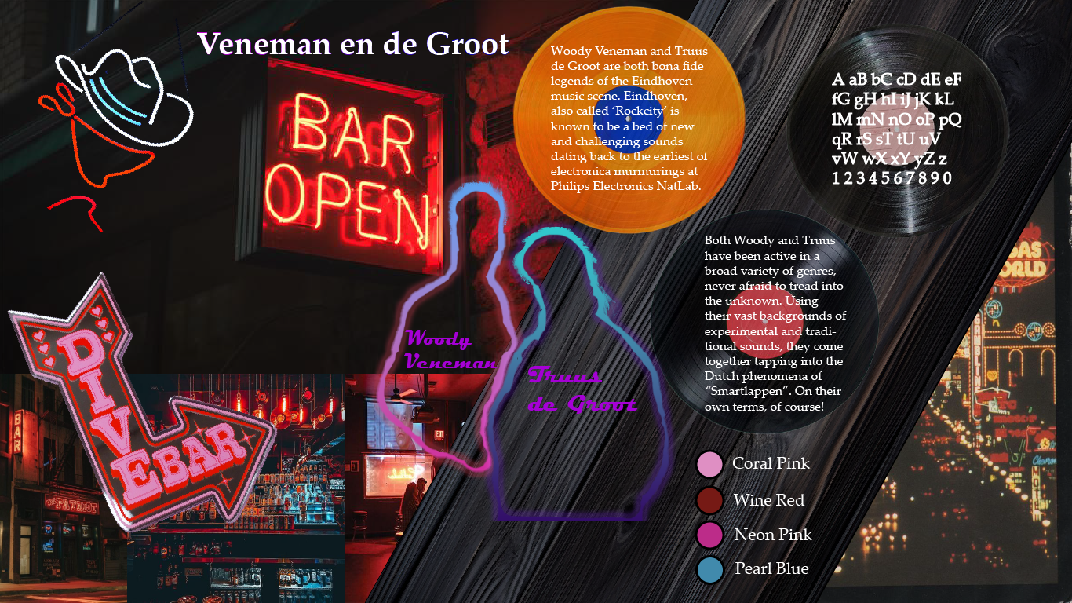

Result
The updated stylescape, which featured a more intimate and emotional color scheme, was well received by Woody during the mid-project presentation. He appreciated the thematic shift toward a softer, love-centered design, which resonated more with his vision for the project. 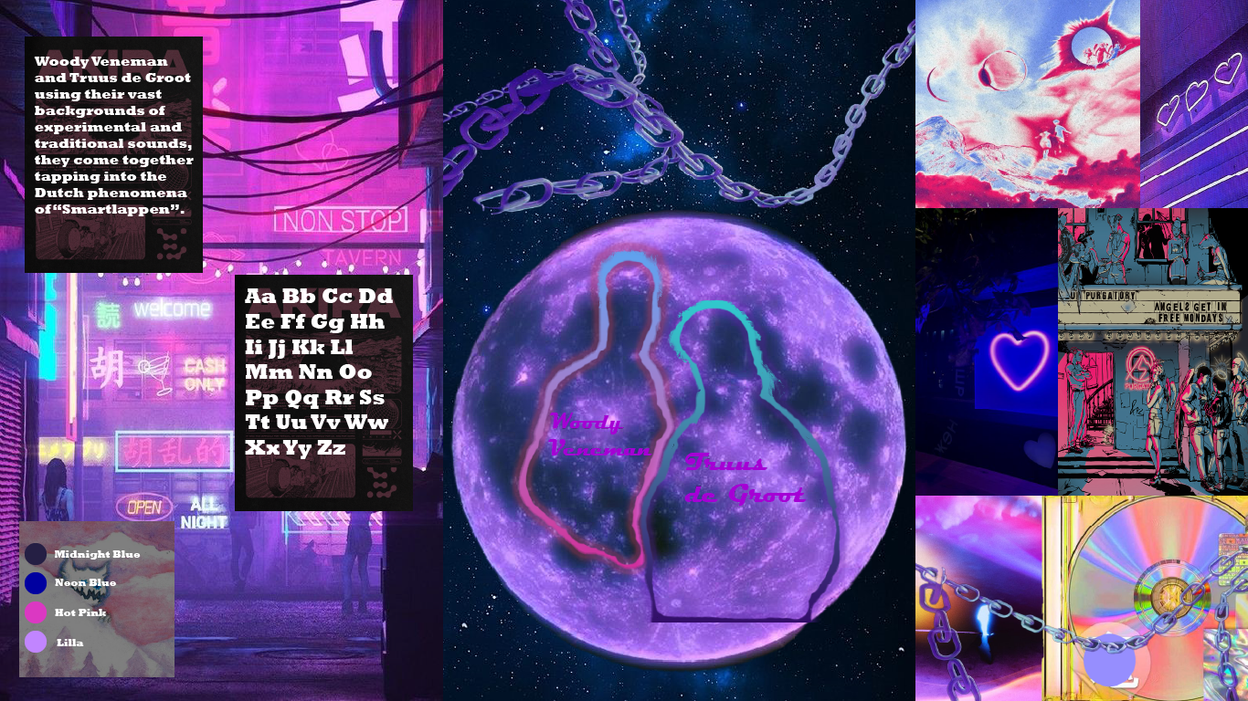
Feedback
Woody provided feedback after the mid-project presentation, expressing his satisfaction with the shift in direction. He pointed out that the new colors and mood aligned better with his vision for neo-smartlappen. He encouraged further exploration of the "love" theme, which led to further refinement of the stylescape to ensure it matched his evolving vision. 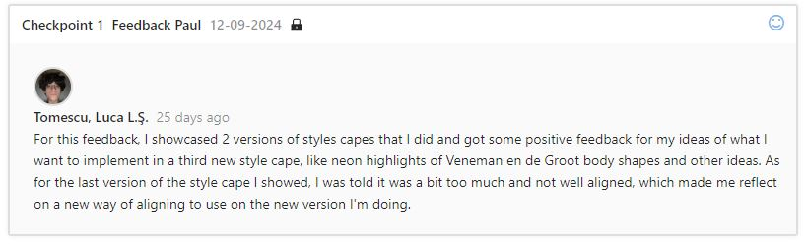
Reflection
This experience highlighted the importance of truly understanding and envisioning the client’s vision. By immersing myself in his music and his genre, I was able to grasp the emotional elements he wanted to see reflected in the stylescape. I realized how crucial it is to remain flexible and open to feedback throughout the design process.
Decide
Moving forward, I will invest more time in understanding the client’s product and vision from the start to create a closer alignment early on. I’ve learned that client feedback can greatly enhance the design process, and it’s essential to iterate based on their evolving needs and preferences. This iterative approach allows me to refine designs that better match expectations and deliver a more meaningful final product.
Final Result

